Riphah International University

Gulberg greens Campus

Submitted by : Mahnoor Ahmed
Sap id : 80207
Submitted to : Mam Nayab Khalid
Lab # 09

Task no.1
You are tasked with designing a transportation system using Object-Oriented Programming (OOP) principles in Java.
1. Abstract Class: Transport
• Define an abstract method move) to represent the movement behavior of different transport types. • Define a concrete method fuelType that prints
"Uses fuel or electricity."
2. Concrete Subclasses:
- ﻿﻿Create a subclass Train that extends Transport:
- ﻿﻿Implement the move method to print "Train runs on tracks." • Create another subclass
Airplane that extends Transport:
• Implement the move method to print "Airplane flies in the sky."
3. Main Method:
- ﻿﻿In the Main class:
- ﻿﻿Create polymorphic references of type Transport for both Train and Airplane.
- ﻿﻿Call move) and fuelType() methods for each object to demonstrate polymorphism and method overriding.

Code:
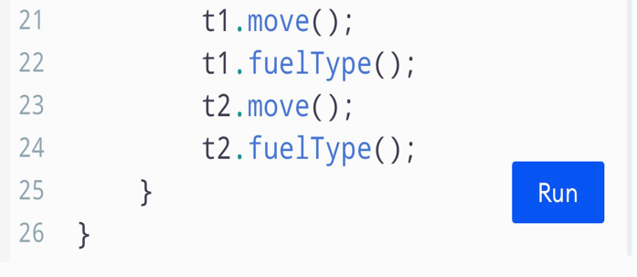
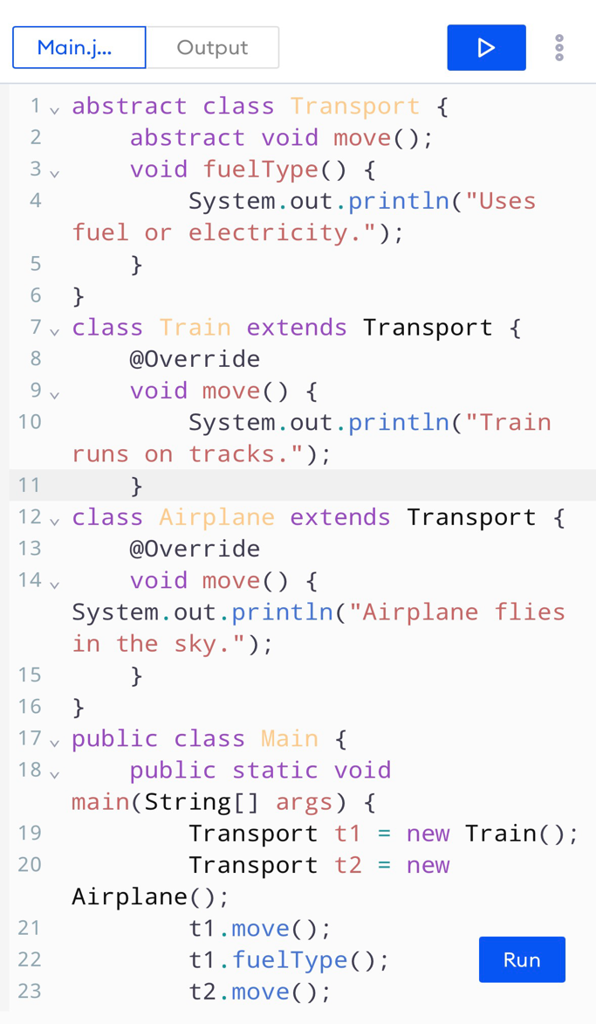
Output:
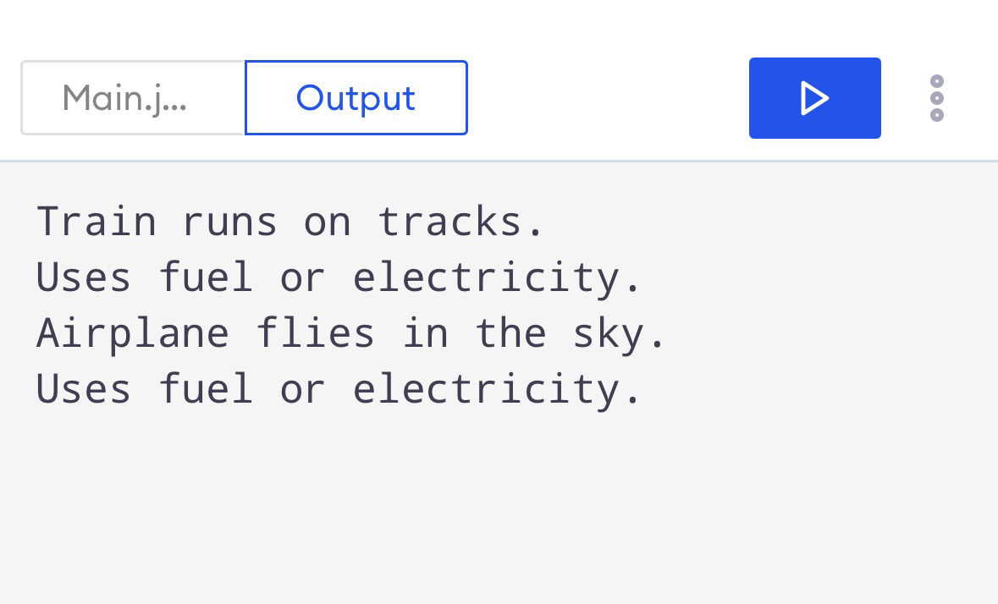

Task no.02
Create an interface named PaymentGateway:
• Declare a method makePayment(double amount).
Implement at least three payment types as classes:
- ﻿﻿CreditCardPayment
- ﻿﻿PayPalPayment
- ﻿﻿UPIPayment
- ﻿﻿Each class should implement PaymentGateway and define custom logic for makePayment) (e.g., print a message showing which payment is being processed).
Create a Main class to test your implementation:
- ﻿﻿Use polymorphism by referencing PaymentGateway while creating objects of the specific payment classes.
- ﻿﻿Call the makePayment) method for each payment type using different objects.

Code :

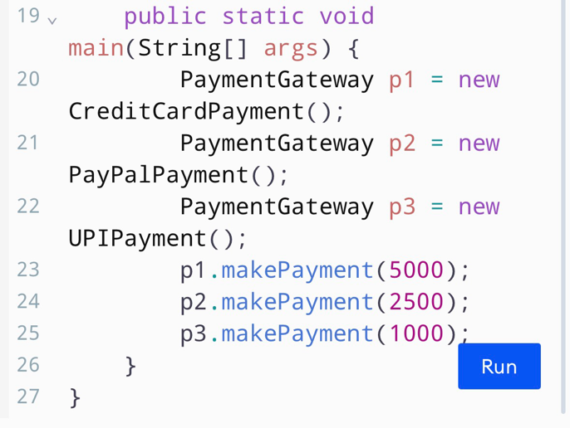
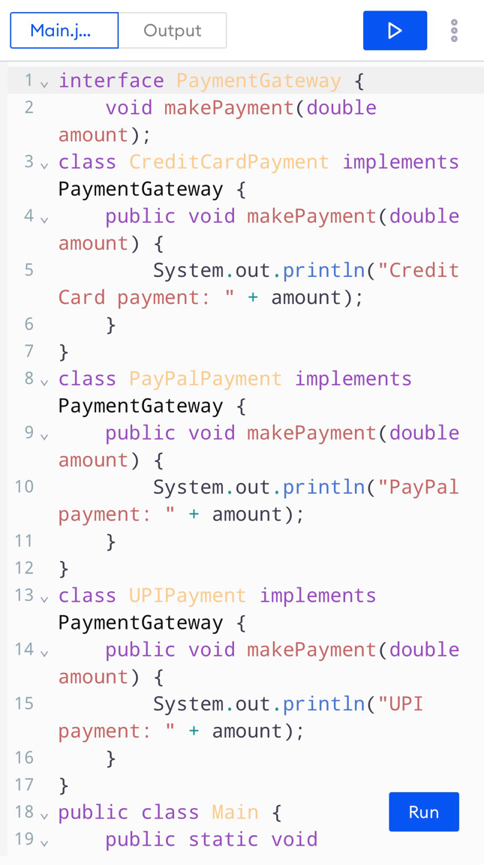
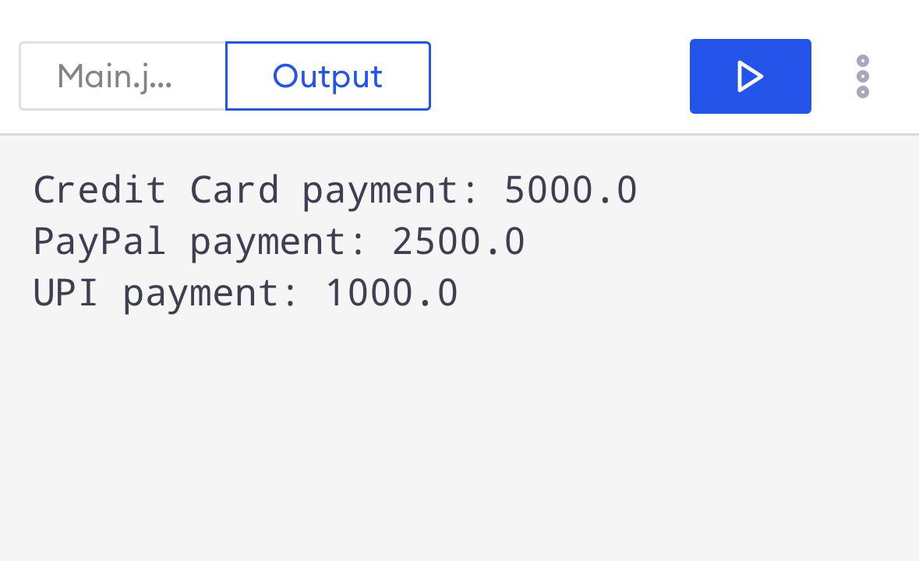
Output:

